OPERATION FALSE ASSURANCE

Team Name | BYEBUST
Phase Number / Title | Phase 2 - OFA P2-07 — Location Service 969
Incident Date | 2025-10-03
Date Submitted | 2026-08-22

REPORT SCORING
No. | Category | Percentage | Points
1 | Executive Summary | 10% | 100
2 | Incident Timeline & Attack Reconstruction | 15% | 150
3 | Victim & Infrastructure Identification | 10% | 100
4 | Technical Investigation, Evidence & Attack Analysis | 55% | 550
5 | Containment, Eradication & Recovery Recommendations | 5% | 50
6 | Report Quality & Professional Presentation | 5% | 50
 | TOTAL | 100% | 1,000
Evidence Requirement: Major findings must be supported by Security Onion, Kibana, Elasticsearch, Zeek, Suricata, or other authorized evidence. Unsupported findings may receive no more than 50% of the available points for that finding.

1. EXECUTIVE SUMMARY
10% - 100 Points
Summarize the activity observed during this phase. State what happened, the affected system, the nature of the malicious activity, and the operational significance.
This report documents a single, focused finding from Operation False Assurance Phase 2: identification of the location-service hostname and URI path contacted by the infected workstation 10.8.20.101 alongside its NetSupport Manager remote-access-trojan (RAT) gateway activity.
Zeek DNS and HTTP logs show the host queried and connected to geo.netsupportsoftware.com, retrieving the path /location/loca.asp via an HTTP GET request that returned a 200 OK response with a 15-byte plain-text body, consistent with a client-geolocation lookup ("loca.asp" = "location ASP" endpoint).
This request occurred within a fraction of a second of the DNS resolution for the RAT gateway domain westford-systems.icu, indicating it is part of the same NetSupport Manager client startup/check-in routine rather than a separate, unrelated action.

2. INCIDENT TIMELINE AND ATTACK RECONSTRUCTION
15% - 150 Points
Record the significant events in chronological order. Use UTC for all timestamps.
Date / Time (UTC) | Source | Destination | Protocol / Port | Activity / Observation
2025-10-03 09:12:56.132 UTC | 10.8.20.101 | 10.8.20.1 (internal DNS) | UDP/53 (DNS) | DNS query for geo.netsupportsoftware.com; 3 A records returned (104.26.0.231, 104.26.1.231, 172.67.68.212 - Cloudflare)
2025-10-03 09:12:56.394 UTC | 10.8.20.101 | 104.26.1.231:80 | TCP/80 (HTTP) | HTTP GET /location/loca.asp, Host: geo.netsupportsoftware.com; response 200 OK, 15-byte body

Attack Reconstruction
Describe how the activity developed during the phase, what the attacker accomplished, and how the available evidence supports the conclusion.
At 09:12:56.132 UTC, host 10.8.20.101 issued a DNS A-record query for geo.netsupportsoftware.com to the internal resolver 10.8.20.1, which returned three answers: 104.26.0.231, 104.26.1.231, and 172.67.68.212 - all Cloudflare, Inc. (AS13335) anycast addresses (Figures 1-2).
Approximately 262 milliseconds later, at 09:12:56.394 UTC, the same host sent an HTTP GET request to 104.26.1.231:80 with Host header geo.netsupportsoftware.com and request URI /location/loca.asp, receiving a 200 OK response with a 15-byte response body (Figures 3-4).
This DNS query and HTTP request occurred essentially simultaneously with the separate DNS resolution of the NetSupport RAT gateway domain westford-systems.icu (also observed at ~09:12:56 UTC per the companion OFA P2-03 finding), indicating both lookups originate from the same NetSupport Manager client startup sequence.
The small, fixed response size (15 bytes) and the /location/loca.asp path are consistent with NetSupport Manager's built-in client-geolocation check-in feature, hosted on the vendor's own Cloudflare-fronted infrastructure rather than attacker-controlled infrastructure.

3. VICTIM AND INFRASTRUCTURE IDENTIFICATION
10% - 100 Points

Affected System
IP Address | 10.8.20.101
Hostname | Not Determined
User Account | Not Determined
Operating System | Not Determined
Active Directory Domain | Not Determined
System Role | Workstation (per exercise scenario: "Infected Workstation")
Status | Confirmed Compromised - NetSupport Manager client location-service check-in (geo.netsupportsoftware.com) time-correlated with the RAT gateway session
Status: Confirmed Compromised / Suspected Compromised / Targeted / Scanned / Not Determined

Relevant Infrastructure
Type | Domain / IP Address | Port | Purpose / Observation
C2 - Remote Access Tool (Domain) | westford-systems.icu | 1203 | Domain observed resolving to the NetSupport gateway IP
C2 - Remote Access Tool (Gateway IP) | 38.146.28.242 | 1203 | NetSupport Manager RAT gateway; resolved answer for westford-systems.icu
Vendor Infrastructure (Location Service - Benign) | geo.netsupportsoftware.com | 80 | NetSupport Manager client geolocation check-in; resolves to Cloudflare (104.26.0.231, 104.26.1.231, 172.67.68.212), not attacker-controlled

4. TECHNICAL INVESTIGATION, EVIDENCE AND ATTACK ANALYSIS
55% - 550 Points
This section contains the main technical findings. Each significant conclusion should be supported by evidence.

4.1 Analyst Findings
No. | Finding / Objective | Answer / Result | Evidence Ref.
1 | Which location-service hostname and URI path were contacted? | Hostname: geo.netsupportsoftware.com -> URI Path: /location/loca.asp (HTTP GET, 200 OK) | Figures 1-4

4.2 Malware / Tool Identification
Malware / Tool / Technique | Evidence | Confidence
NetSupport Manager v1.3 (legitimate remote-support tool abused as a RAT) | zeek.dns shows a single query for geo.netsupportsoftware.com (3 Cloudflare A records); zeek.http shows one GET /location/loca.asp to 104.26.1.231:80 (200 OK, 15-byte body) - consistent with the NetSupport Manager client's built-in geolocation check-in (Figures 1-4) | High
Technical analysis:
The NetSupport Manager client performs a location lookup against its own vendor infrastructure (geo.netsupportsoftware.com/location/loca.asp) as part of its startup/check-in behavior. This is a legitimate, documented NetSupport feature rather than attacker-built infrastructure, but its presence and timing are a useful corroborating indicator that a genuine NetSupport Manager client (not a generic HTTP-based RAT) is running on the infected host.

4.3 Network Activity
Time (UTC) | Source IP | Destination IP | Port | Protocol | Domain / Host | Observation
2025-10-03 09:12:56.132 UTC | 10.8.20.101 | 10.8.20.1 | 53 | DNS | geo.netsupportsoftware.com | A-record query; 3 answers, all Cloudflare (AS13335)
2025-10-03 09:12:56.394 UTC | 10.8.20.101 | 104.26.1.231 | 80 | HTTP | geo.netsupportsoftware.com (resolved) | GET /location/loca.asp; 200 OK, response_body_len 15
Analysis:
The geo.netsupportsoftware.com DNS query and the subsequent HTTP GET to 104.26.1.231:80 both originate from host 10.8.20.101 and occur within 262ms of each other, and within the same second as the DNS resolution of the RAT gateway domain westford-systems.icu - tying this location-service request to the NetSupport RAT session on this host (Figures 1-4).

4.4 Command-and-Control Activity
C2 Domain / IP | Port | Protocol | First Seen | Observation
westford-systems.icu / 38.146.28.242 | 1203 | HTTP (NetSupport Manager) | ~2025-10-03 09:49 UTC (earliest of most-recent 10 of 48 events reviewed) | NetSupport Manager RAT beacon (CMD=POLL, CMD=ENCD) to /fakeurl.htm; gateway IP confirmed via DNS resolution of westford-systems.icu (single A record, no other domains observed resolving to this IP)
Assessment:
The location-service request itself (geo.netsupportsoftware.com/location/loca.asp) is directed at NetSupport's own Cloudflare-hosted infrastructure and is not, by itself, a C2 channel; it is assessed as legitimate client telemetry/geolocation behavior of the NetSupport Manager software, occurring alongside - and timestamp-correlated with - the actual RAT C2 gateway session to 38.146.28.242:1203.

4.5 Files and Payloads
Filename | Source / URL | Type | Observation
Use “Not Determined” when the exact filename or content cannot be confirmed from the available evidence.

4.6 Credential Collection / Exfiltration
Collection Method
Information Collected
Exfiltration Method
Destination
Protocol / Port
Assessment:
________________________________________________________________________________
________________________________________________________________________________

4.7 Lateral Movement
Time (UTC) | Source | Destination | Port / Protocol | Activity
State whether the destination was merely contacted, targeted, or confirmed compromised.
________________________________________________________________________________
________________________________________________________________________________

4.8 Ransomware Activity
Ransomware Family
Initial Source
First Target
Propagation Protocol
Destination Port
Exploit / Technique
Additional Propagation Sources
Affected Systems
First Observed Time
Last Observed Time
Assessment:
________________________________________________________________________________
________________________________________________________________________________
________________________________________________________________________________

4.9 Indicators of Compromise
Indicator | Type | Purpose / Assessment | Recommended Action
westford-systems.icu | Domain | Resolves to the NetSupport Manager RAT gateway | Block/sinkhole domain; add to DNS blocklist
38.146.28.242:1203 | C2 IP:Port | NetSupport Manager RAT gateway (resolved from westford-systems.icu) | Block at perimeter firewall/proxy; add to blocklist
geo.netsupportsoftware.com / /location/loca.asp | Location-Service Hostname + URI (benign, vendor infra) | NetSupport Manager client geolocation check-in; timing anchor for client startup (~09:12:56 UTC) | No blocking action; retain as a corroborating/timing indicator alongside the malicious gateway IOCs

4.10 Investigation Evidence
Query / Filter Used: event.dataset:zeek.dns && dns.query.name:"geo.netsupportsoftware.com" | event.dataset:zeek.http && http.virtual_host:"geo.netsupportsoftware.com"
Security Onion Hunt (Elasticsearch): event.dataset:zeek.dns && dns.query.name:"geo.netsupportsoftware.com" and event.dataset:zeek.http && http.virtual_host:"geo.netsupportsoftware.com" (time range: last 365 days)
Finding:
Exactly one DNS query and one HTTP transaction match: dns.query.name = geo.netsupportsoftware.com (3 A records, all Cloudflare), and http.virtual_host = geo.netsupportsoftware.com with http.method GET and http.uri /location/loca.asp - confirming the location-service hostname and URI path contacted.

Evidence Reference: Figures 1-4
Kibana / Elasticsearch
Alerts / Suricata
Time (UTC) | Alert | Source | Destination | Remarks
2025-10-03 09:12:56 UTC | No Suricata alert triggered for this request (benign vendor traffic) | 10.8.20.101 | 104.26.1.231:80 (geo.netsupportsoftware.com) | Identified via Zeek DNS/HTTP metadata only; included here for timeline correlation with the NetSupport RAT gateway session
Zeek Logs Used
- [x] conn
- [x] dns
- [x] http
- [ ] ssl / tls
- [ ] smtp
- [ ] files
- [ ] dhcp
- [ ] kerberos
- [ ] smb
- [ ] other: Suricata eve.json alerts (imported)
Relevant observation:
Expanding the zeek.http record confirms http.method: GET, http.uri: /location/loca.asp, http.virtual_host: geo.netsupportsoftware.com, http.status_code: 200, and http.response.body.length: 15 (Figures 3-4); the groupby dns.resolved_ip query (Figure 2) confirms all 3 resolved addresses belong to Cloudflare, Inc.

4.11 Evidence Register
Evidence No. | Description | Source
E-01 | Security Onion Hunt - event.dataset:zeek.dns && dns.query.name:"geo.netsupportsoftware.com": Total Found 1, confirming the DNS lookup at 09:12:56.132 UTC. | Zeek (via Security Onion)
E-02 | Security Onion Hunt - groupby dns.resolved_ip: 3 Cloudflare addresses (104.26.0.231, 104.26.1.231, 172.67.68.212). | Zeek (via Security Onion)
E-03 | Security Onion Hunt - event.dataset:zeek.http && http.virtual_host:"geo.netsupportsoftware.com": summary row, GET to 104.26.1.231:80, 200 OK. | Zeek (via Security Onion)
E-04 | Security Onion Hunt - expanded zeek.http event record: http.uri = /location/loca.asp, http.virtual_host = geo.netsupportsoftware.com. | Zeek (via Security Onion)
E-05 | Not applicable to this focused finding. | Other
Each screenshot should include a short caption explaining what it shows.

4.12 MITRE ATT&CK Mapping
Tactic | Technique | Technique ID | Evidence
Command and Control | Remote Access Software | T1219 | NetSupport Manager RAT beacon traffic to 38.146.28.242:1203 (Figure 1)
Command and Control | Application Layer Protocol: Web Protocols | T1071.001 | HTTP-based C2 beacon (CMD=POLL/CMD=ENCD to /fakeurl.htm)
Reconnaissance / Discovery | System Location Discovery | T1614 | NetSupport Manager client geolocation check-in to geo.netsupportsoftware.com/location/loca.asp (Figures 1-4); vendor-hosted, used here as a client-startup timing anchor

5. CONTAINMENT, ERADICATION AND RECOVERY
5% - 50 Points
Provide recommendations based on the findings from this phase.

Immediate Actions
1. Record geo.netsupportsoftware.com / /location/loca.asp as a benign-but-relevant NetSupport Manager client indicator (timing anchor), distinct from the malicious C2 gateway westford-systems.icu / 38.146.28.242:1203.
2. Do not block geo.netsupportsoftware.com or its Cloudflare IPs, as this is vendor infrastructure; instead use this request's timestamp to help establish the NetSupport client's startup time on 10.8.20.101.
3. Correlate this finding with the broader Phase 2 investigation and the companion OFA P2-03/P2-04 reports (RAT gateway domain and beacon request pattern).

Additional Recommendations
Network:
No blocking action required for geo.netsupportsoftware.com (legitimate vendor CDN); continue to block/sinkhole the confirmed malicious gateway 38.146.28.242:1203 and domain westford-systems.icu per the companion reports.
Endpoint:
Hunt for NetSupport Manager artifacts (installed software, running processes) on 10.8.20.101 and peer hosts; the presence of a geo.netsupportsoftware.com lookup can help confirm genuine NetSupport Manager client installations elsewhere in the environment.
Accounts / Credentials:
Not applicable to this focused finding.
Active Directory, if applicable:
Not Determined.
Recovery:
See the main Phase 2 investigation report for host-level recovery recommendations.

6. CONCLUSION
Provide the team’s final assessment of the phase. State what happened, what system was affected, what the attacker accomplished, the evidence supporting the conclusion, the impact, and how this phase relates to the larger incident.
This focused investigation confirmed that infected workstation 10.8.20.101 contacted the location-service hostname geo.netsupportsoftware.com at URI path /location/loca.asp via HTTP GET, receiving a 200 OK response with a 15-byte body.
This request is assessed as legitimate NetSupport Manager client behavior (a geolocation check-in against the vendor's own Cloudflare-hosted infrastructure), not attacker-controlled C2 traffic.
Its evidentiary value lies in timing: the DNS lookup for geo.netsupportsoftware.com occurred within the same second as the DNS resolution of the actual RAT gateway domain westford-systems.icu, corroborating that a genuine NetSupport Manager client started up on 10.8.20.101 at approximately 09:12:56 UTC on 2025-10-03.
This finding supports the broader Phase 2 conclusion that 10.8.20.101 was compromised and actively used for attacker remote access via NetSupport Manager.
This finding should be read alongside the main Phase 2 report and the companion OFA P2-03 (gateway domain) and OFA P2-04 (repeated HTTP request) reports.

7. EVIDENCE LIMITATIONS
List any information that could not be confirmed from the available data. Do not present assumptions as confirmed facts.
The exact contents of the 15-byte HTTP response body from /location/loca.asp (e.g. a country code, city name, or coordinate pair) were not extracted or examined in this pass, as file/body carving was out of scope for this focused finding.
Whether the NetSupport Manager client on 10.8.20.101 was legitimately installed or was dropped/installed by the attacker as part of the intrusion was not independently determined from network evidence alone.

8. APPENDICES

Appendix A - Investigation Queries
Query:
Query 1: event.dataset:zeek.dns && dns.query.name:"geo.netsupportsoftware.com" (Security Onion Hunt, Last 365 days) - confirms the DNS lookup for the location-service hostname.
Query:
Query 2: event.dataset:zeek.dns && dns.query.name:"geo.netsupportsoftware.com" | groupby dns.resolved_ip (Security Onion Hunt) - lists the 3 resolved Cloudflare addresses.
Query:
Query 3: event.dataset:zeek.http && http.virtual_host:"geo.netsupportsoftware.com" (Security Onion Hunt) - returns the single HTTP transaction; expand the record to view http.method and http.uri.

Appendix B - Figures and Screenshots
Use sequential figure numbers. Each figure should include a short caption describing what the evidence demonstrates.
Figure 1

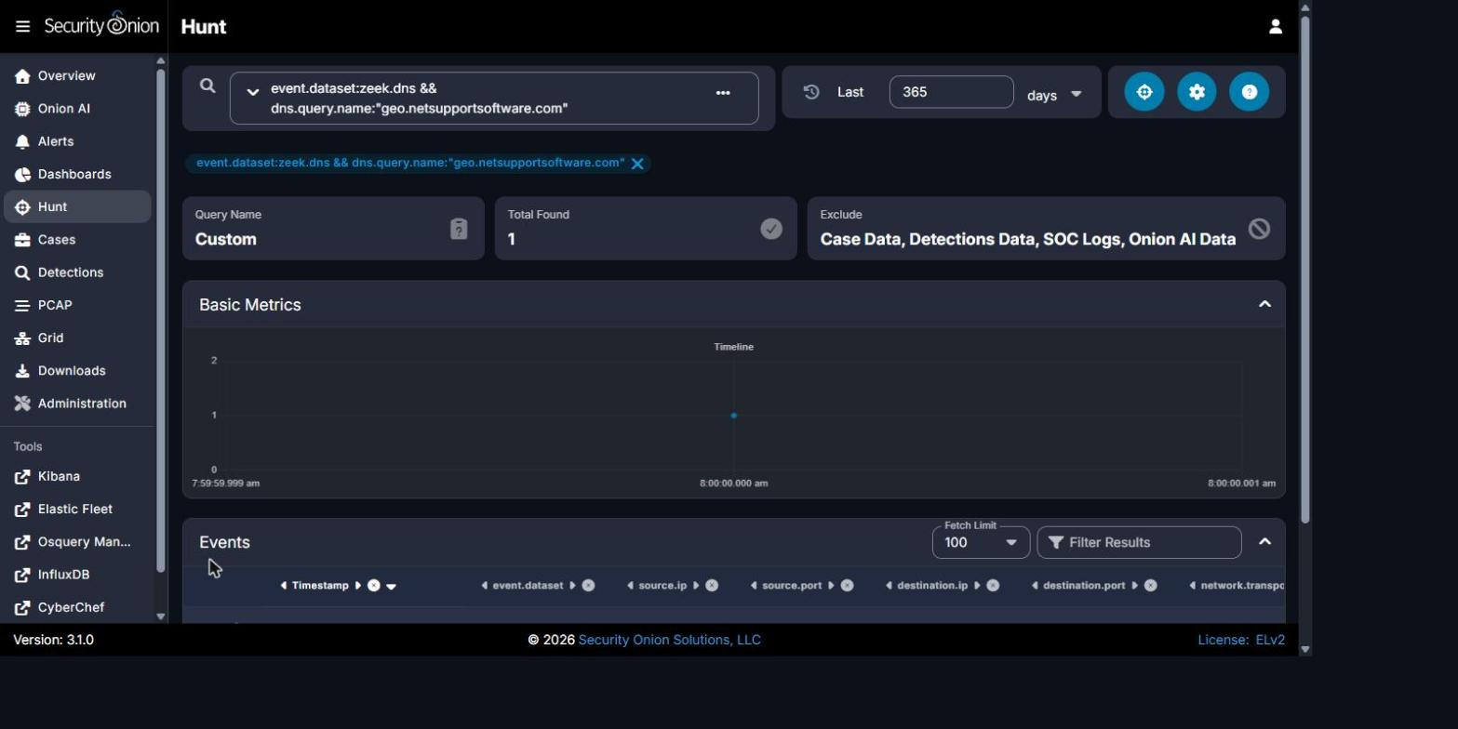
Security Onion Hunt - event.dataset:zeek.dns && dns.query.name:"geo.netsupportsoftware.com": Total Found 1, query bar and result confirming the DNS lookup from 10.8.20.101 at 09:12:56.132 UTC.
Figure 2

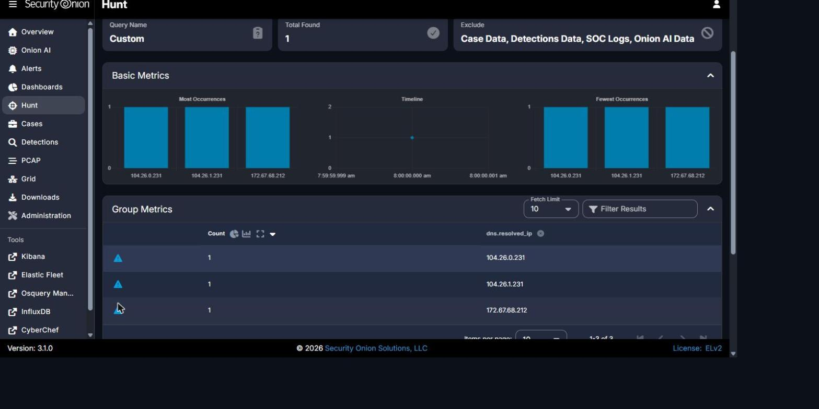
Security Onion Hunt - event.dataset:zeek.dns && dns.query.name:"geo.netsupportsoftware.com" | groupby dns.resolved_ip: 3 resolved addresses (104.26.0.231, 104.26.1.231, 172.67.68.212), all Cloudflare, Inc.
Figure 3
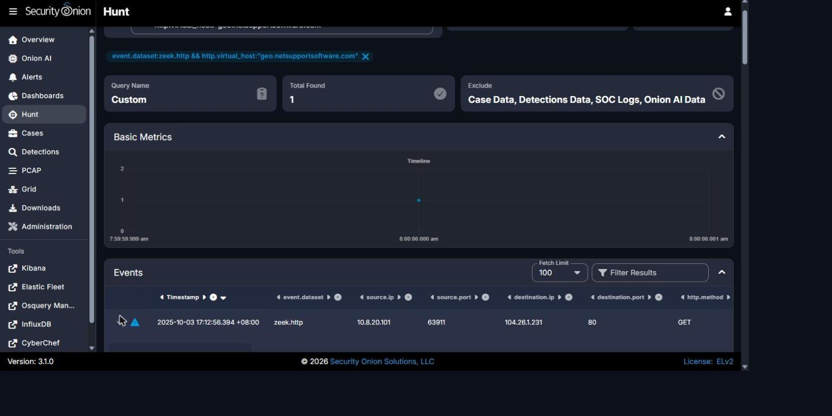
Security Onion Hunt - event.dataset:zeek.http && http.virtual_host:"geo.netsupportsoftware.com": summary row showing GET request to 104.26.1.231:80, status 200 OK.
Figure | Caption / Description
Figure 1 | Security Onion Hunt - event.dataset:zeek.dns && dns.query.name:"geo.netsupportsoftware.com": Total Found 1, query bar and result confirming the DNS lookup from 10.8.20.101.
Figure 2 | Security Onion Hunt - event.dataset:zeek.dns && dns.query.name:"geo.netsupportsoftware.com" | groupby dns.resolved_ip: 3 resolved addresses, all Cloudflare, Inc.
Figure 3 | Security Onion Hunt - event.dataset:zeek.http && http.virtual_host:"geo.netsupportsoftware.com": summary row showing GET request to 104.26.1.231:80, status 200 OK.
Figure 4 | Security Onion Hunt - expanded zeek.http event record: http.uri = /location/loca.asp, http.virtual_host = geo.netsupportsoftware.com.
Figure 4
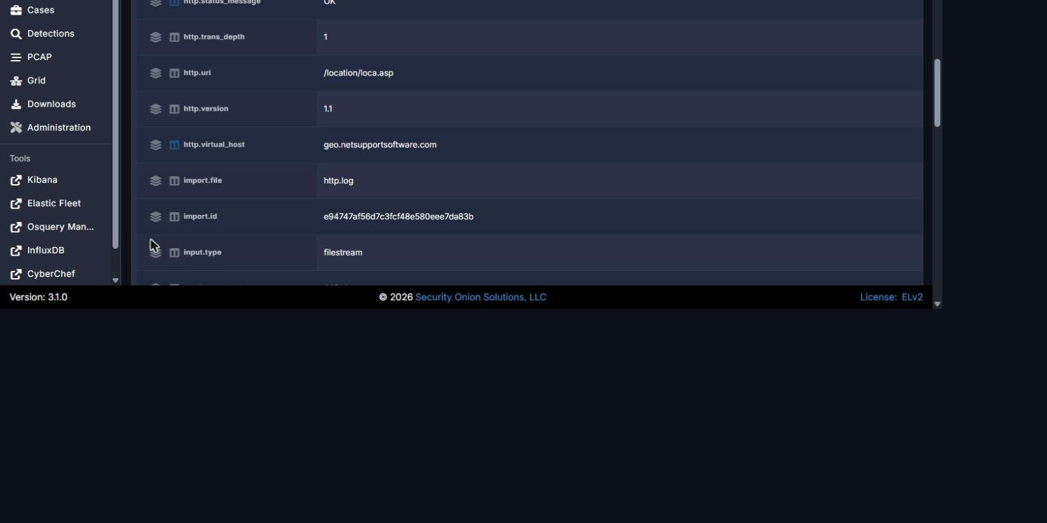
Security Onion Hunt - expanded zeek.http event record: http.uri = /location/loca.asp, http.virtual_host = geo.netsupportsoftware.com.

REPORT QUALITY REQUIREMENTS
5% - 50 Points
- Clear and logical organization
- Correct technical terminology
- Accurate use of timestamps
- Readable screenshots
- Properly labeled tables and figures
- Consistent evidence references
- Clear distinction between confirmed facts and analyst inference
- Professional presentation and readability

SUBMISSION INSTRUCTIONS
1. Submit one report for each phase designated as Report-Required.
2. Submit the final report in PDF format unless otherwise directed.
3. Clearly indicate the team name, phase number, and phase title.
4. Use UTC for timestamps.
5. Major findings must be supported by evidence.
6. Screenshots must be numbered and captioned.
7. Do not include executable malware samples in the report.
8. State 'Not Determined' when a finding cannot be confirmed.
9. Ensure all screenshots, tables, and text are readable.
10. Reports must be submitted before the deadline announced by exercise control.
Evidence Rule: A correct finding without supporting Security Onion, Kibana, Elasticsearch, Zeek, Suricata, or other authorized evidence may receive no more than 50% of the points assigned to that finding. Incorrect or fabricated evidence receives zero points for the affected finding.

